**CHAPTER 6**

**RESULTS AND DISCUSSIONS**

**6.1 SNAPSHOTS OF THE PROJECT AND DESCRIPTION**



**Fig 6.1.1: Home Page**

Home page consists of a search bar with task bar having home and add details buttons.



**Fig 6.1.2: Insert page**

Fig 6.1.2 shows the insert page of the website.

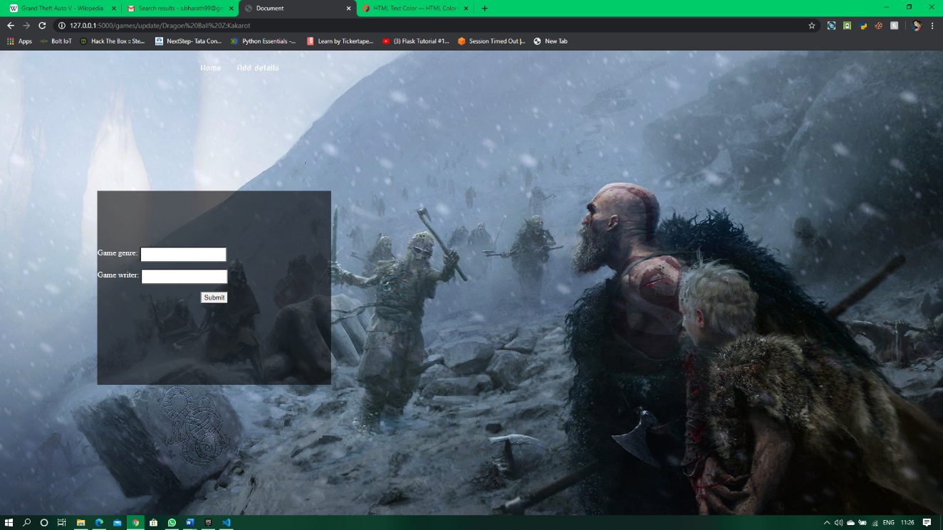

**Fig 6.1.3: Update page**

Fig 6.1.3 shows the update page when the user chooses to update.



**Fig 6.1.4: Display page**

Fig 6.1.4 shows the Display page after searching or inserting the details.

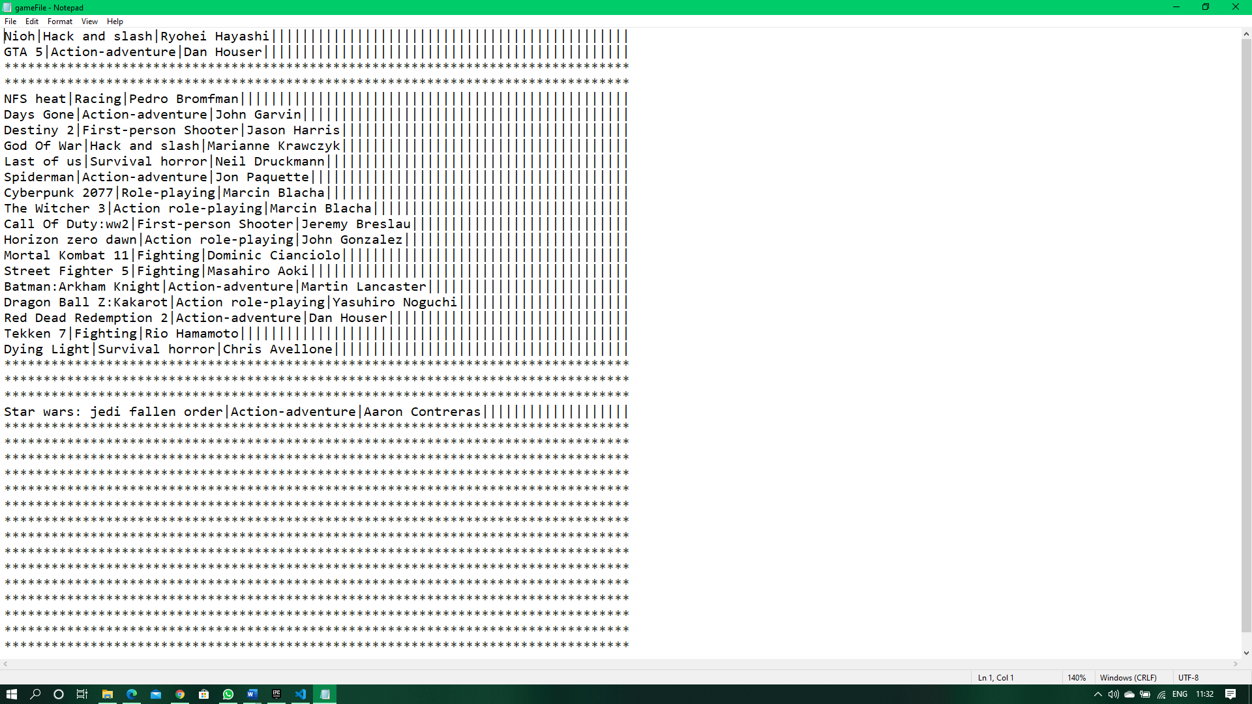

**Fig 6.1.5: Game file**

Fig 6.1.5 is the file where game details are stored.



**Fig 6.1.6: Publisher file**

Fig 6.1.6 is the file where publisher details are stored.

**Fig 6.1.7: Hero search page**

## OBSERVATION ABOUT PROJECT

The project is observed to correctly perform the operations as of user requirements like search, add, display, delete, modify. The details when entered by the user for addition is appended to the respective file. The user can search any game data by entering the game name in the search tab. If the search is successful then the details of the game is displayed. The user can view 2 options in the display page to update the same data or delete the same. When the user chooses to delete the record is deleted form the respective file and the user is redirected to the home page. If the user chooses to update, the user is redirected to the update page where the user is required to provide with new details. Once the details are provided the user is redirected to the display page.

**6.3 ADVANTAGES OF HASHING:**

• Hashing provides a more reliable and flexible method of data retrieval than any other data structure.

• It is faster than searching arrays and lists.

• Hash tables are particularly efficient when the maximum number of entries.

• Storage is reduced.

**6.4 DISADVANTAGES OF HASHING:**

* Performance decreases when load factor is more.
* Collision may cluster, and this requires traversing the hash table one element at a time to find next available.

• Some keys such as floating points can lead to long chains and prefixes are not particularly meaningful.

## APPLICATION OF HASHING

Some applications are Message Digest, Password Verification, Compiler Operation, Rabin-Karp algorithm, Linking File name and path together.